To pass this course item, you must receive 100%, or 1 out of 1 point, by completing the activity below. You can learn more about graded and practice items in the [course overview](https://www.coursera.org/learn/prepare-for-cybersecurity-jobs/supplement/KvQW2/course-8-overview).



**Activity Overview**

In this activity, you will answer two common **behavioral interview questions** using the STAR method.

As you've learned, the STAR method is a helpful strategy for answering behavioral interview questions in a clear, organized, and engaging way. STAR stands for “situation,” “task,” “action,” and “result.” In an interview, you may be asked behavioral interview questions. These types of questions require you to share a time when you were faced with a particular situation or had to practice a certain skill.

Be sure to complete this activity before moving on. The next course item will provide you with a completed exemplar to compare to your own work.

**Scenario**



Review the following information. Then complete the step-by-step instructions.

When you use the STAR method to answer behavioral interview questions during an interview, interviewers get a better sense of who you are as a candidate and why you’ve applied for the role. The STAR method can make your responses easier for them to follow by creating a logical structure to each story you share. Preparing and practicing responses using the STAR method in advance can also help you feel more confident going into an interview.

In this activity, you will prepare responses to two common behavioral interview questions. First, you will recall and record notes about experiences you’ve had in the past that demonstrate your key skills. Then, you will select two questions from a list of behavioral questions frequently asked during interviews. You will answer each of these questions using the STAR method. Finally, you have the option to practice answering these questions and others aloud in front of a mirror, friend, or family member.

**Step-By-Step Instructions**



Follow the instructions and answer the question below to complete the activity. Then, go to the next course item to compare your work to a completed exemplar.

**Step 1: Access the template**



To use the template for this course item, click the following link and select *Use Template.*

Link to template: [STAR responses worksheet](https://docs.google.com/document/d/1FWZ8bsmaz2JvzWfGNOhS8qCNZL9Y7nozekZUZ9us5CY/template/preview?usp=sharing&resourcekey=0-JK8_xEsivsJ2WSidYecHlg)

OR

If you don’t have a Google account, you can download the template directly from the following attachment.

[STAR responses worksheet](https://d3c33hcgiwev3.cloudfront.net/kbzLJxxNTayqbDn6YF3TSw_e4e692ac0b21455fa48bdc315fa7a8f1_STAR-responses-worksheet.docx?Expires=1720483200&Signature=UwEJN8xipcZpHpc~HtaUwRKsAdJ5EZMZ-nhUjedTTS3EnedgAYRgve9Hy2-mW7lYkhgXAKD~kW083SgMQ1j0LtRS9a8dTzll9-dVQhR1tn-9WuXiVW9gHj9g2avbyVuH1J-s1LSfa-ihMqJPu5ssN84hdgj7P69HrK9BpEvG03A_&Key-Pair-Id=APKAJLTNE6QMUY6HBC5A" \t "_blank)

[DOCX File](https://d3c33hcgiwev3.cloudfront.net/kbzLJxxNTayqbDn6YF3TSw_e4e692ac0b21455fa48bdc315fa7a8f1_STAR-responses-worksheet.docx?Expires=1720483200&Signature=UwEJN8xipcZpHpc~HtaUwRKsAdJ5EZMZ-nhUjedTTS3EnedgAYRgve9Hy2-mW7lYkhgXAKD~kW083SgMQ1j0LtRS9a8dTzll9-dVQhR1tn-9WuXiVW9gHj9g2avbyVuH1J-s1LSfa-ihMqJPu5ssN84hdgj7P69HrK9BpEvG03A_&Key-Pair-Id=APKAJLTNE6QMUY6HBC5A" \t "_blank)

**Step 2: Identify experiences that demonstrate your skills**

Research the most commonly sought skills cybersecurity analysts have by reviewing job descriptions on platforms like [Indeed](https://www.indeed.com/), [LinkedIn™ Job Search](https://www.linkedin.com/jobs/), and/or [CareerBuilder](https://www.careerbuilder.com/). Then, consider the experiences you’ve had that demonstrate those types of skills. These may be past work experiences, school projects, volunteer positions, or any other relevant activities you’ve done—even the completion of this program.

Add notes on at least three of those experiences to the **Experiences** **that demonstrate my skills** section of the STAR responses worksheet.

**Step 3: Select interview questions**

During a job interview, you may be asked behavioral interview questions. Your answers to these questions should demonstrate how you handled a specific situation in the past and indicate how you might handle a similar situation in the future.

Review the list of **Common Behavioral Interview Questions for Cybersecurity Analysts** on the second page of the STAR responses worksheet.

Consider which two questions would allow you to describe the experiences you recorded in **Step 2**. Then, copy the two questions and paste them in the **Question 1** and **Question 2** sections of the template.

**Step 4: Describe the situation**

The STAR method can help you organize your responses in a story-like structure.

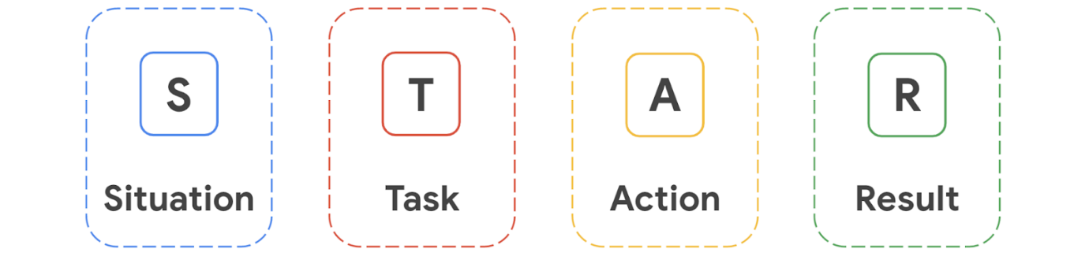

First, review the experiences you listed at the top of the worksheet. Select one of the experiences and add it to the **Situation** section of Question 1. Write 2-3 sentences answering the question.

**Pro tip:** Be as specific as possible, providing enough detail to help the interviewer understand the context in which the situation took place.

**Step 5: Describe your task**

In the **Task** section, add 1-2 sentences that relate the situation to a *task* that you were required to complete.

For example, describe what you were asked to do, how you were involved, or what you were responsible for. Try your best to explain exactly how you fit into the story you’re telling.

**Step 6: Explain the actions you took**

The *action* section of the STAR method is your chance to highlight your role in solving the problem for your interviewer.

Complete the **Action** section of Question 1 by writing a short paragraph (2-4 sentences) that describe the action(s) you took to accomplish the task. Give specific details that demonstrate your abilities and skills. This part of your response may take the most time to cover, since you can highlight multiple skills here.

**Step 7: Share your results**

Finally, it's time to share the conclusion of your story by summarizing what you achieved.

In the **Results** section of Question 1, add a short paragraph (2-4 sentences) describing the outcome of the actions you took and the impact you had. When possible, use data—such as numbers and percentages—to reinforce your response. If you’re sharing an experience that came with challenges, you may also want to share the lessons you learned.

**Step 8: Answer the second question**

Repeat steps 4–7 to answer **Question 2** using the STAR method.

**(Optional) Step 9: Practice your responses aloud**

Finally, to prepare yourself to answer these types of questions verbally, practice your answers out loud in front of a mirror or with a friend or family member. Try answering additional questions from the list of **Common Behavioral Interview Questions for Cybersecurity Analysts** in the same manner.

**Pro Tip: Save the template**

Be sure to save a blank copy of the STAR responses template you used to complete this activity. You can use it for further practice or as you prepare for professional interviews. This template will help you work through your thought processes and demonstrate your experience to potential employers.

**What to Include in Your Response**



Be sure to address the following criteria in your completed STAR responses:

* A description of three **experiences** that showcase your skills
* A selection of two **interview questions** to answer
* A description of the following as it relates to each question:
  + A **situation** you experienced (two to three sentences)
  + The **task** you were asked to complete or your responsibility in the situation (one to two sentences)
  + The **actions** you took to meet the challenge or solve the problem (two to four  sentences)